PARTICIPATIVE LEARNING

Monday, 25 October 2021

A Lecture on Mahatma Anand Swami organized at HMV
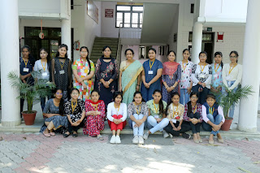

The Sanskrit Department of HMV Collegiate Senior Secondary School, Jalandhar organized a lecture on Life, Literature & Teachings of Mahatma Anand Swami Ji under the able guidance of Principal Prof. Dr. (Mrs.) Ajay Sareen. Principal Dr. Ajay Sareen addressed the students and said that Mahatma Ji is such a lighting lamp which can enlighten our life too. The life of Swami Ji is very inspirational. It is the duty of every person to read his life journey. It is the duty of every person to protect truth. Swami ji gave very valuable teachings through his literature. She said that young generation should know about his teachings. School Coordinator Mrs. Meenakshi Sayal also shared his life, struggle, simplicity, truthfulness & sacredness. She inspired the students to take lessons from his life. Head of Sanskrit Department Dr. Meenu Talwar told the students about the life & teachings of Mahatma Anand Swami Ji. She said that it is our duty to follow his teachings in our life. On this occasion. Km. Vibhuti, Km. Dhanyashree, Km. Bhumika Pandey shared their views about Swami Ji’s life. Km. Chahat, Km. Dhanyashree, Km. Arshia, Km. Premjeet presented a Bhajan. Mrs. Anuradha presented vote of thanks.

Monday, 13 June 2022

HMV Organized Skilled Course Certificate Programme in Personality Development and Soft Skills Training – Beginner’s Level

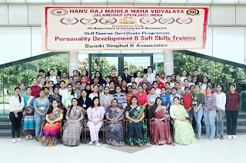
Commerce Club of P.G. Department of Commerce and Management of Hans Raj Mahila Maha Vidyalaya, Jalandhar organised a skilled course certificate programme in Personality Development and Soft Skills Training in collaboration with Swinki Singhal and Associates, under the able guidance of Principal Prof. Dr. (Mrs.) Ajay Sareen. As per the tradition of HMV, Programme started with Gaytri Mantra to seek blessings of Almighty. The session began with formal welcome and green greetings by Coordinator Ms. Binoo Gupta, Dean Student Welfare, Ms. Shefali Kashyap and Ms. Kanika Sharma, Incharges Skill Programme. Ms. Binoo Gupta, Coordinator of the programme briefed that such programmes aimed at enabling students to explore their hidden potential and helps in grooming their personality. Total 72 students from B.Com and B.B.A participated in the program. Various training sessions were conducted by CA Swinki Singhal. Students were guided on Time Management, Stress Management, Goal Setting and Public Speaking. Practical knowledge was imparted through Mock Telephonic Conversation, Role Plays, Group Discussion. They were also told about Wardrobe Management, Corporate Readiness, Handling and Surviving in Corporate Environment. Students were involved through various fun activities and video clips to provide experiential learning. Students Km. Mehak, Km. Deepali , Km. Apporva and Km. Diksha were honoured by CA Swinki Singhal for their active participation. On the valedictory day Principal Prof. Dr. (Mrs.) Ajay Sareen congratulated the participants and the Organizing Committee and told that the prime focus of our institution is to make the students self-sufficient & independent and it was achieved through such programmes. Mrs. Meenu Kohli, Head PG Department of Commerce and Management encouraged students to join such programmes for their personal grooming and to enhance self confidence. Vote of thanks on the concluding day was given by Ms. Shefali Kashyap and Ms. Kanika Sharma, course incharges. Stage was conducted by Ms. Anmol and Ms. Shayna Monga. Technical assistance was provided by Mr. Vidhu Vohra. Dr. Seema Khanna, Ms. Kajal Puri, Ms. Shilpa Goyal and Ms. Sonal graced the occasion with their presence.

Friday, 1 October 2021

HMV organized exhibition on Best Out of Waste

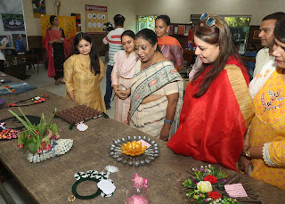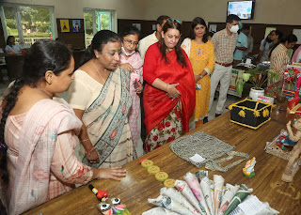

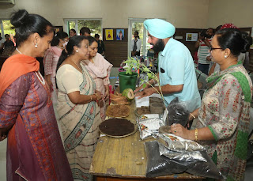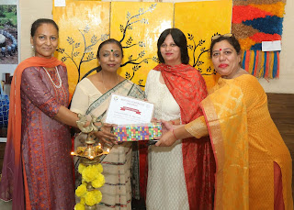

Hans Raj Mahila Maha Vidyalaya, Jalandhar organized one day exhibition on “Best out of waste” in collaboration with Municipal Corporation, Jalandhar under Azadi Ka Amrit Mahotsav. People from different areas of Jalandhar participated in the exhibition. Number of artistic articles were displayed in the exhibition using waste material. There were two categories i.e. Entrepreneur and Common Society. The Chief Guest of the exhibition was Dr. Sumita Abrol, Assistant Health Officer, Municipal Corporation, Jalandhar. Ms. Ramanpreet Kaur, Programme Coordinator Swachh Bharat Mission (Urban), Mrs. Rekha Kashyap, T.V. artist & Mrs. Monika Sekri, Senitary Inspector, Municipal Corporation, Jalandhar were also present. Principal Prof. Dr. (Mrs.) Ajay Sareen said that we all should be aware about recycling. HMV has been tagged as Green Champion and organize Best Out of Waste programme from time to time. She said that the motive of this exhibition is not only to inhance the creativity of artists but to promote entrepreneurship as well. She gave her blessings to all the participants. Dean Innovation Dr. Anjana Bhatia said that such programmes are helpful in promoting the creativity and entrepreneurship in artist. HMV always take a stepahead in such programmes. Around 100 schools participated in this exhibition. The students made different things with Paper Brush, Bottles, Old mats, Newspapers, CDs etc. The children of Special School also participated in this exhibition and competition. In Entrepreneur Category Mr. Harpreet Singh got 1st prize and Ms. Ramanpreet Kaur got 2nd prize. In 2nd category Team Ridhi got 1st prize, Sudipa got 3rd prize, Plasha got 4th prize, Sahil got 5th prize, Khushi got 6th prize and shruti got 7th prize. Consolation prize was won by Ritika Joshi, Ashi, Divya & Diya. The Incharges of the programme were Dr. Rakhi Mehta, Mrs. Navneeta, Co-Incharge Dr. Shailender Kumar.

Sunday, 26 June 2022

HMV ORGANIZED ONE DAY EDUCATIONAL TRIP TO NAKODAR

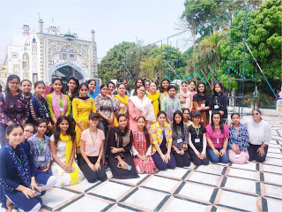
Under the guidance of Principal Prof. Dr. Mrs. Ajay Sareen one day educational trip to Nakodar was conducted by Bachelor of Design Department of Hans Raj Mahila Maha Vidyalaya, Jalandhar for outdoor study, Nature Study, Market Survey and to visit Power loom weaving units. Water Color demonstrations, Pencil and Charcoal shadings, Architectural study and Photography were done at Dera Baba Murad Shahji. Local Market of Nakodar for Cotton Yarns, Furnishing Material and Powerloom-Handloom fabrics was surveyed. Visit to power loom weaving unit, New Dana Mandi Nakodar was also done by faculty members Dr. Rakhi Mehta, Ms. Gurdeep Kaur, Ms. Harpreet Kaur and students of B. Design. Principal Dr. Sareen appreciated the efforts of Design Department and told the students about the importance of such trips during student life. She said that such trips provide wonderful opportunity to learn and explore nature. The Trip was very fruitful and students explore new dimensions of Textile world.

Wednesday, 22 June 2022

Successful completion of first batch of CPBFI in HMV
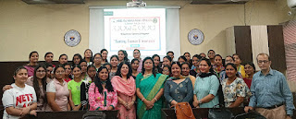
The Commerce Club of Hans Raj Mahila Maha Vidyalaya, Jalandhar organized Skilled Course Certificate Programme in Banking, Finance and Insurance (CPBFI) in collaboration with Bajaj FinServ under the able guidance of Principal Prof. Dr. (Mrs.) Ajay Sareen, Mrs. Binoo Gupta, Coordinator of the course told the purpose of conducting this course was to enhance the employability skills of the students. She told that during the span of 46 days of the online course, the students were given insights into the practical aspects of Banking, Finance, insurance and interview conduct. The course was divided into four modules comprising managing selfSwaRoop, Communication and workplace skills, overview of retail banking and overview of finance. Overall 49 students benefitted from the programme. Principal Dr. Ajay Sareen appreciated the efforts of the team members comprising Mrs. Meenu Kohli, Head of Department, Mrs. Binoo Gupta, Incharge Commerce Club and Course Coordinator and Course Incharges - Mrs. Savita Mahendru and Dr. Minakshi Duggal Mehta. Mrs. Binoo Gupta expressed gratitude to Ms. Archana, Head, Training Operations, CPBFI, Mr. Kanwaljit Singh, Lead Trainer of CPBFI in Punjab, training experts Mr. Chintamani, Mr. Narahar Deshpande, Mr. Ashwani Kumar Puri, Ms. Kanika Kapahi and Technical team Mr. Raja Decruz, Shital Gaikwad, Mr. Bikramjit Singh, Mr. Sanjib Deb, Mr. Dakshina Moorthy and Mr. Vidhu Vohra for coordinating in the successful completion of the programme

Thursday, 23 June 2022

HMV Organized Annual Art Exhibition
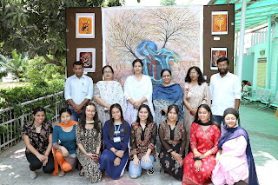
Under the aegis of Punjab Government’s DBT Star Scheme for Colleges and seeking the able guidance of Principal Prof. Dr. (Mrs.) Ajay Sareen, a seven day Faculty Development Programme (FDP) on ‘Guru Siddhta’ was started on 24th June, 2022 in the premises of Hans Raj Mahila Maha Vidyalaya, Jalandhar. The event was commenced by following the ceremony of holy lamp and DAV gaan. Justice (Retd.) Sh. N.K. Sood – Vice President of DAV College Managing Committee and Chairman Local Committee and Dr. Satish Ahuja – Principal Director of DAV Institute of Management, Faridabad made their presence as the chief guests of the occasion. In the first session of FDP, Dr. Aneesh Dua – Dean students’ Welfare, Zoology Department, Guru Nanak Dev University Amritsar and in the second session, Dr. Maisha Sikka – Dietician, Tagore Hospital, Jalandhar were the Chief Guests. Principal Prof. (Dr.) Mrs. Ajay Sareen welcomed the Chief Guests by presenting them planters. Further, Dr. Ajay Sareen stressed upon the importance of Faculty Development programme and said that knowledge seeks no age. She said, a student’s life is really indispensible in which they learns many techniques and methods in order to make their life complete. A real teacher can be one who teaches his students by using convincing tools and pedagogy. In addition to this, Dr. Satish Ahuja focused upon the essentials of Faculty Development Programme and said that such sorts of learning programmes enhance the personality of a teacher. Justice (Retd.) Sh. N.K. Sood also presented his views and remarked that a teacher is the reason of producing doctors, engineers and officers. Therefore, a Teacher is the highly-esteemed personality in our society. In the first session of FDP, Dr. Aneesh Dua discussed about the contemporary requirements in the teaching-learning process. Moreover, he said, a teacher must be a role model for his students. We should not present teaching profession as a burden. We should also indulge ourselves in learning something new so that our education system could be strengthened. In the second session of FDP, Dr. Manisha Sikka presented her views on balanced diet. She said, if we follow a balanced and healthy diet in our day to day life then we can render our services in a correct manner. A healthy life helps in the completion of every work. Dr. Anjana Bhatia was the coordinator for the occasion. Progamme Convener Mrs. Saloni, Organizer Dr. Harpreet Singh, Incharge of Core Committee Dr. Seema Marwaha, Dr. Neelam Sharma, Dr. Anil Bhasin, Dr. Jatinder Kumar, Mrs. Gagandeep, Dr. Rakhi Mehta, Mr. Ashish Chadha were also present. Mrs. Saloni Sharma, Head Physics Department presented vote of thanks.

Wednesday, 18 May 2022

HMV Organized Industrial Visit to Foodcoast International, Focal Point

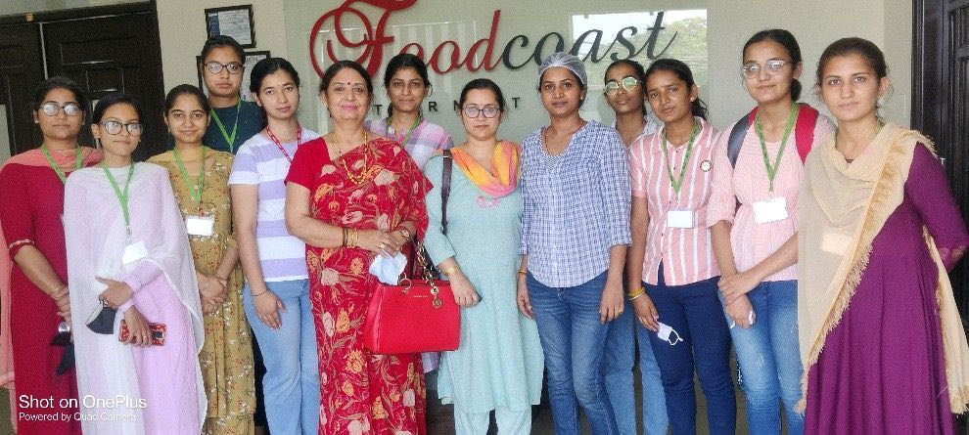
C.V. Raman Science Society of Science Department of Hans Raj Mahila Maha Vidyalaya, Jalandhar organized an industrial visit to Foodcoast International, Focal Point, Jalandhar under the able guidance of Principal Prof. Dr. (Mrs.) Ajay Sareen. Dr. Neelam Sharma, Head, Chemistry Department and Dr. Vandna Thakur accompanied students from M.Sc. Chemistry and B.Sc. Final Year to visit the Foodcoast International which is a leading manufacturer of mayonnaise, ketchups, spreads, salad dressings, Indian gravies, toppings and crushes of Indian and World cuisines in bulk. Mr. Sushant Sharma, M.D. facilitated the visit to the company. Ms. Suman Thakur, Senior HR Manager co-ordinated the tour of plant. Students toured the automated hi-tech plant and learned the complete process starting from raw material to the preparation and its packaging. Mr. Pramod Kumar, Manager, Production Process, and Mr. Manish, Manager, Quality Control, explained every step and process of the plant, working of machinery in detail to the students. Students also visited the quality control laboratories and learned about the various tests done to check the quality of raw materials and the final products. Principal Prof. Dr. (Mrs.) Ajay Sareen said that it is our objective to provide practical exposure to students and industry academia interface is also possible through such visits. Students interacted with the experts during the visit who shared their knowledge resulting in very informative discussion.

Department of Biotechnology
Report on One Day Industrial Visit to Verka Milk Plant, Jalandhar
Session 2021-22
One day industrial visit was organized by the Department of Biotechnology on Dated 19-4-2022 for the students of B.Sc.Biotechnology (Sem IV and V).During this visit students have learnt various microbiological, biochemical and biophysical, bioprocess engineering techniques like pasteurization, hazard analysis critical control point (HACCP), sterilization etc. used to prepare different milk products like curd, cheese, yoghurt,flavoured milk etc.They were also sensitized about various microbiological and biochemical test like IMVIC Test, methylene blue reduction time test(MBRT), total plate count, fat analysis, casein content, crude protein analysis etc. performed in their laboratory for determination of quality control parameters of milk and their products. Students were also shown the working of industrial scale operations like agitation, aeration, and heat plate exchanger, demonstration of dry milk powder preparation etc.Further they were also shown the working and management of different divisions of the plants concenered with packaging of different milk products, storage of products with latest advance techniques like automated chillers at extremely low temperature conditions and handling techniques employed to maintain proper quality of the various milk products. All the processes and techniques used at the plant were explained to the students by the experts of the quality control divisions of the plant and the students have learnt the processes and techniques in a throughway.
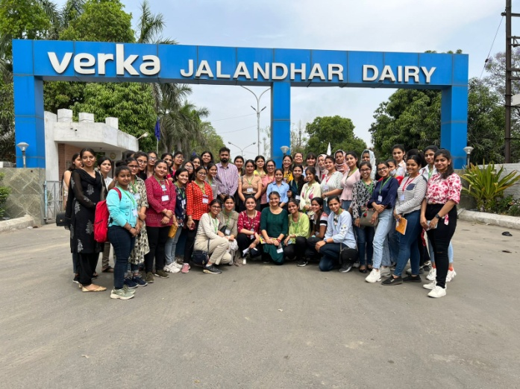
This visit was especially organized as same has been mentioned as a part of their curriculum of both the classes prescribed by GNDU, Amritsar, and further Mr.Sumit Sharma Assistant Professor, Department of Biotechnology has accompanied the students for this industrial cum educational visit.

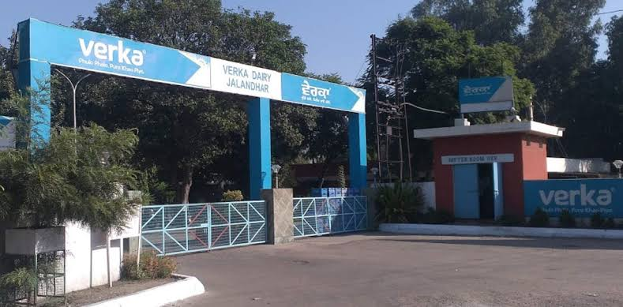

Verka is a flagship brand of MILKFED and came into being in 1973 when MILKFED was mandated for milk procurement, quality processing of milk & its products and marketing of these products. Verka was christened after the name of the place where the first was set up in Amritsar. A trusted brand, Verka has become a household name and is loved by it's customers for nutrition and quality. It has consolidated it's brand strength by not only retaining the high quality of existing products but also by innovating and bringing new products to the table of its diverse customers.
Vision & Mission of the Verka
Vision of the Verka is to become the most admired brand in the dairy sector and the vibrant cooperative institution in the country facilitating inclusive growth.
Ensuring prosperity to the milk producers by ensuring milk procurement at remunerative prices around the year coupled with providing quality extension services for enhancing milk production as well as reducing costs. Ensuring quality processing of milk and production of milk products in a clean, hygienic manner and making them available to the consumers at reasonable prices through excellence in marketing.
The Verka milk has a mission to provide technical support activities to each farmer at his door step and to bring them out from clutches of dojhies and other middlemen. Currently Verka sources the milk from over 3,50,000 members of around 6,300 village milk producers cooperative societies.
Range of the products offered:-
Verka has wide range of products including different variants of Pasteurized packed milk, Ghee, Butter, Skimmed milk powder, Whole milk powder, Cheese, Sweetened flavoured milk, Ice-Cream, Indigenous sweets, Fresh products like Lassi, Paneer, Dahi, Kheer.
Distribution network
The products of Verka are available in Punjab, Harayana, Himachal Pradesh, Jammu& Kashmir. Verka also exports Ghee to countries like Australia , Japan , New Zealand , Malaysia. Milk Union Jalandhar is also meeting the requirement of Defence Forces.
Certification awarded
Verka stands apart, with its promise of purity, in the milk testing by NABL, accredited laboratory, Verka Gold has topped the full Cream Milk category with a score of 88 out of 100.An ISO-9002 and IS-15000 certification has been accredited to Doaba Milk Union by the Bureau of Indian Standards.

Details of the visit:Commerce Club of Post Graduate Department of Commerce and Management has organised an industrial and excursion trip to Verka Milk Plant, Jalandhar and Wonderland, Jalandhar on 14 May, 2022. Total 57 students from BcomSem II, IV & BBA Sem II and IV visited with two faculty members Mrs.YuvikaMidha and Mrs.RituBahri. The team was accorded a warm welcome by General Manager Mr.Asit Sharma. The teachers presented a planter and planner to him on the behalf of the college.
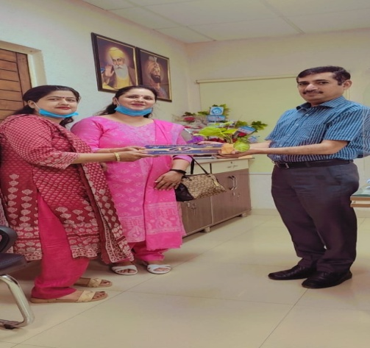
The visit started with a round of different sections of organization wherein students were given practical insight into production and packaging aspects of Verka products. Ms.Nandini,Assistant Manager Production explained various processes for preservation and pasteurization of milk, production of cheese, curd, kheer, butter, lassi and desi ghee. Mrs.AmardeepKaur, Deputy Manager Production and Mr.Jatinder Pal Singh, Deputy Manager Production explained about the procurement of inputs and supply of the output via. variousdistribution channels. Apart from this they highlighted the importance of the organisation for the marginal farmaers. A planter and planner on behalf of the college were presented to them.
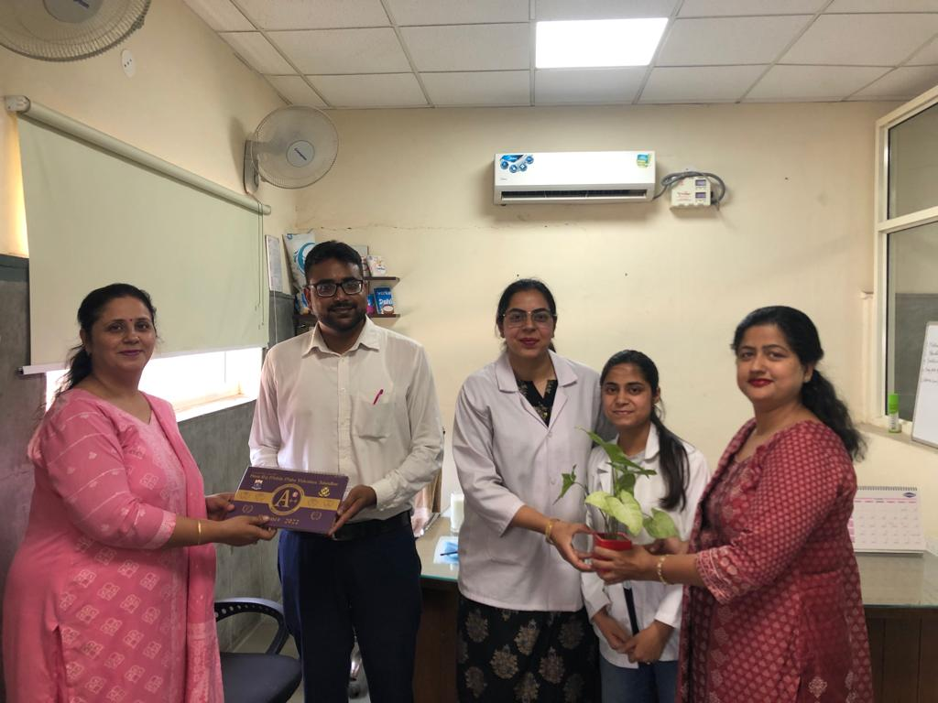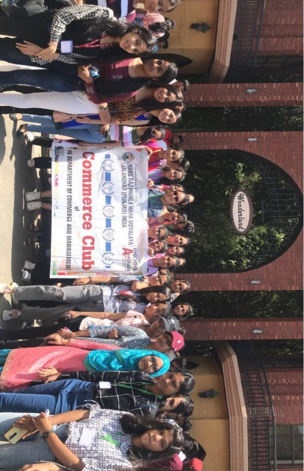

PG DEPARTMENT OF FASHION DESIGNING
INDUSTRY VISITS/STUDY TOURS/FIELD VISITS
SESSION:2021-2022
On 20th November 2021
An educational visit was organized to SKM industry and Vishal Mega Mart at Jalandhar. Students of B.Sc fashion Designing Sem I, III and B.voc Fashion Technology Sem I, III & V were taken to visit it. Students learnt how buyers and manufactures from all over India deal about fashion merchandise. Students also learnt about sampling to production techniques. To experience the marketing and sales strategies of local vendors and retailers, students were taken to V-Mart Jalandhar. Ms. Deepika Miglani and Ms. Rupvinder Kaur accompanied the students for visit.
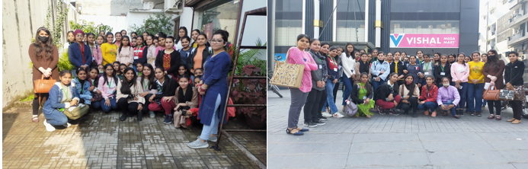
On 28th November 2021
An educational visit to “Pushpa Gujarat Science City” was organized by “Commerce Club” in which students of PG Department of fashion designing have accompanied with other students of commerce club. They have learnt about new innovations in science and Technology. Students of B.Sc. Fashion designing Sem-III also visited there faculty of commerce club also accompanied the students.
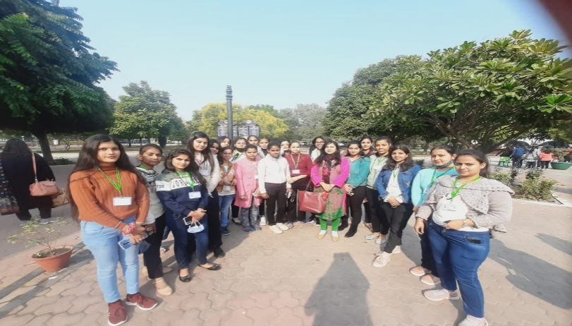

Tours/ Visits of Physics Department (2021-2022)
- NIGHT SKY WATCH (15-11-2021)
The Chandrayaan Vipnet Club of Physics department, Hans Raj MahilaMahaVidyalaya, Jalandhar organized “Night Sky Watch” on 15th November, 2021 from 5:00 PM to 8:30 PM at IT Conference ground. Total 127 students of various streams of the college participated in this life time experienced event. HOD PG deptt. of Physics Mrs. Saloni Sharma and faculty members welcomed the Resource Persons, Mr. Akashdeep Singh (Incharge of Night Sky Watch) and his technical assistant Mr. Manpreet Singh from Pushpa Gujral Science city with a planter.
The HOD of physics department Ms. Saloni Sharma explained the students about Chandrayaan Vipnet Club and its activities. The event commenced with the fascinating videos, demonstrating the journey of two space probes named “Voyager1” and “Voyager 2” launched by NASA as a voyager program to study the outer solar system and interstellar space beyond the Sun’s heliosphere. “Voyager2” was launched on 20 August 1977, whereas, Voyager 1 was launched on 5 September 1977. After watching the videos, students seem eager to explore more about the universe.
In order to satisfy the curiosity of students Mrs. Saloni Sharma gave a power point presentation on “Universe and Celestial Bodies” to make them aware about the composition of our Solar System. She explained the Big Bang theory and creation of all the planets as well as their moons in a very remarkable manner. She told the students that Sun is about 149 million km away from Earth and the diameter of Sun is 109 times the diameter of Earth. Size of the other planets was also compared with that of the Sun. Basically her talk pivots around the moon (natural satellite of earth), Venus (third planet), Jupiter (fifth planet) and Saturn (sixth planet). Venus has the densest atmosphere consisting of 96% carbon dioxide. So, even though Mercury is closest to sun, Venus has the hottest surface of any planet in the solar system, with a temperature of 737 k. It is also known as the morning star and evening star. Jupiter is gas giant and is the first largest planet, mainly made up of hydrogen and helium. Being the second largest planet, Saturn is also a gas giant with an average radius of about nine and half times that of Earth. It only has one-eighth the average density of Earth; with its larger volume, Saturn is over 95 times more massive. She has also added the discussion of different phases of moon. To explore the awareness among the students regarding space research a small quiz was also conducted.
After the discussion, students couldn’t contain the excitement to see surface of moon and the three planets together. Mr. Akashdeep Singh and his assistant set the high power telescope in the college lawn to focus on moon, Venus, Uranus and Saturn. Faculty members of the college and students viewed the beautiful craters on the surface of moon, crescent phase of planet Venus, Jupiter with its five moons and the Saturn with beautiful rings. Students explored moon and planets patiently and everybody was seemed to be fascinated to see this magnificent spectacle. On this event, physics faculty, Mr. Sushil, Dr. Simmi Garg, Ms. Nidhi Pathak and Ms. Vidhi were also present.
Principal Prof. Dr.(Mrs.) Ajay Sareen applauded the Physics department for organizing such an innovative event.
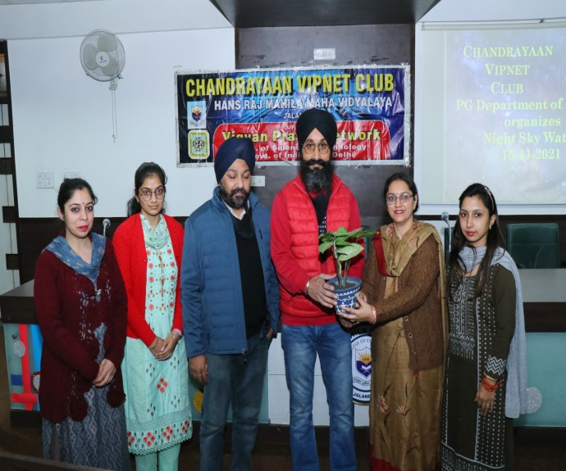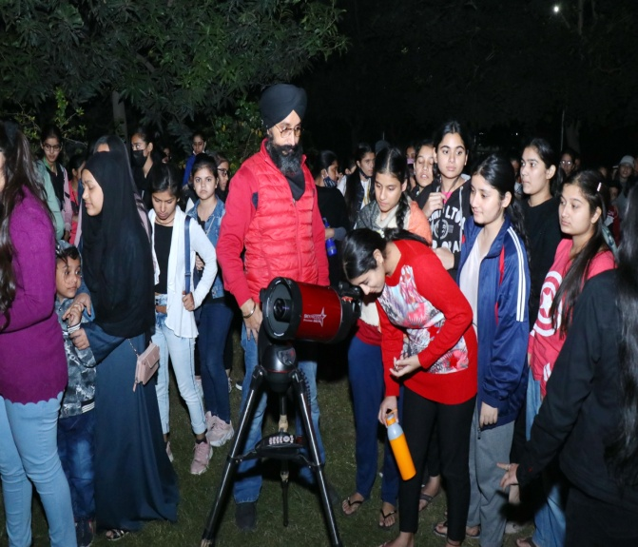
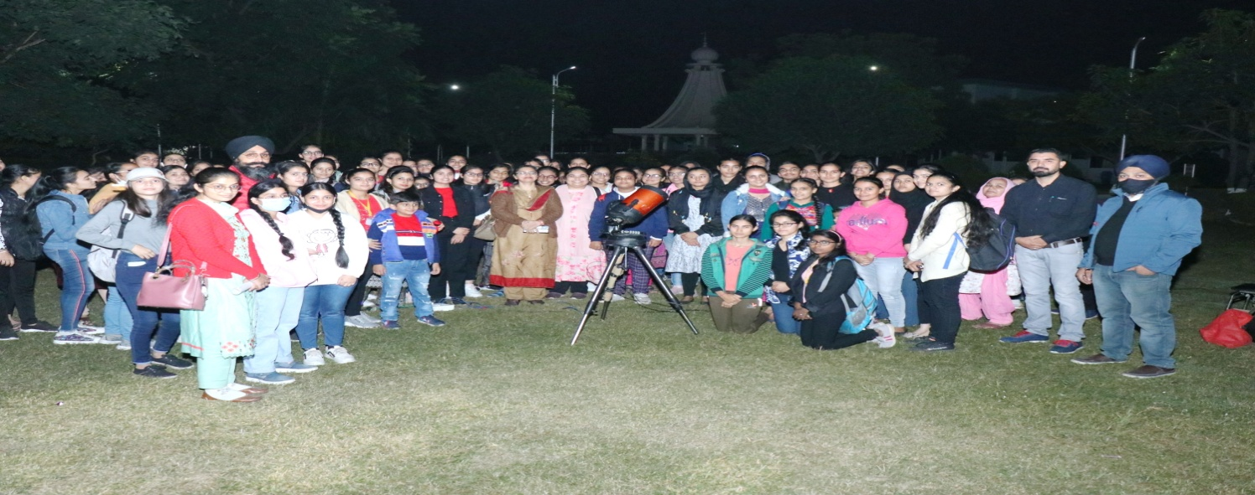

One Day Educational Visit to National Institute of Renewable Energy, Kapurthala on 29th April 2022
Chandrayaan Vipnet Club of PG Department of Physics organized a one day educational visit. A team of 48 students accompanied by two teachers Mrs. Saloni Sharma and Mr. Sushil Kumar to Sardar Swaran Singh National Institute of Renewable Energy (SSS-NIRE), Kapurthala (Punjab) on 29th April, 2022. Spread over a sprawling campus of about 75 acres, the carries out and facilitates research, design, development, testing, standardization & technology demonstration eventually leading to commercialization of RD&D bio fuel. Students visited four research laboratories operational on synthesis, characterization and testing of biofuels Bioenergy and synthetic fuels in solid, liquid and gaseous forms for transportation, portable and stationary applications as well asDevelopment of hybrid/integrated energy systems based on solar energy and wind energy. They learnt about the various processes for production of Bio-fuel in chemical conversion R&D Lab and Bio-Chemical conversion of R&D Lab, Designing,testing experimental efficiency of different models of Cook Stoves developed at NIRE and improving biomass Cookstove.In the hybrid/integrated energy systems labs, students learnt about working of solar panels for conversion of solar energy to electricity and various control factors for improving the output of solar panels. They also learnt about the application of Solar Panels for heating water in Solar Water heaters/Geysers. Students also saw the working model of Wind Mill, learnt about finding the threshold speed of wind required for converting wind energy to electricity.The students also interacted with Post Doc researchers as well as Research Scientist, to learn from their experience. Some students also enquired about the various study paths to get into such research institutes.The visit was very informative and students were motivated to undertake research as a career and utilize their knowledge for betterment of Society. After the educational visit the students also visited Gurudwara Baba Ber Sahib at Sultanpur Lodhi . Principal Dr. ( Mrs.) Ajay Sareen motivated the students to participate in more such visits to have practical experience and exposure with such research labs. She also congratulated the Faculty of the department on successfully organizing the trip.
